**Two-Person Relays  
Position 1**

1. How many positive integers have a value between and ? 6
2. 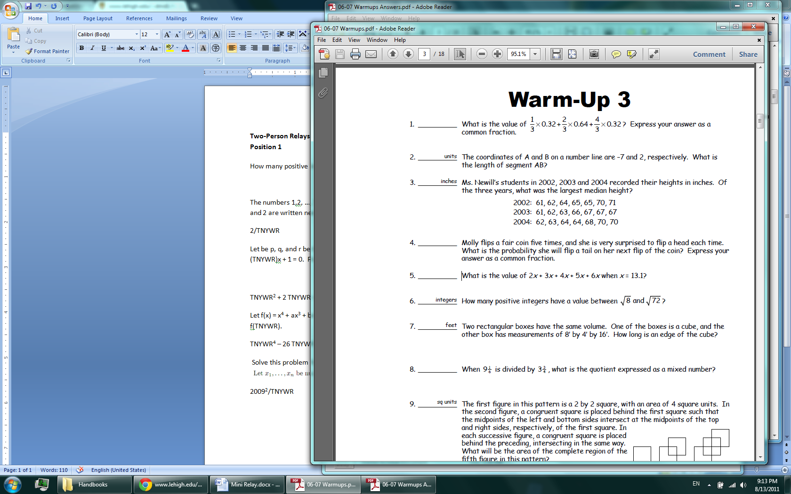24 / 25
3. Marcy bought 120 apples for $24. When she got home, she discovered that 1/5 of the apples were rotten. If she figures she spent the $24 on only the good apples, how many cents did each good apple actually cost? 25
4. The price of a stereo is $200 on Monday. On Tuesday the price from Monday is reduced by 10%. On Wednesday, Tuesday’s price is increased by 10%. What is the price of the stereo on Wednesday? 198
5. 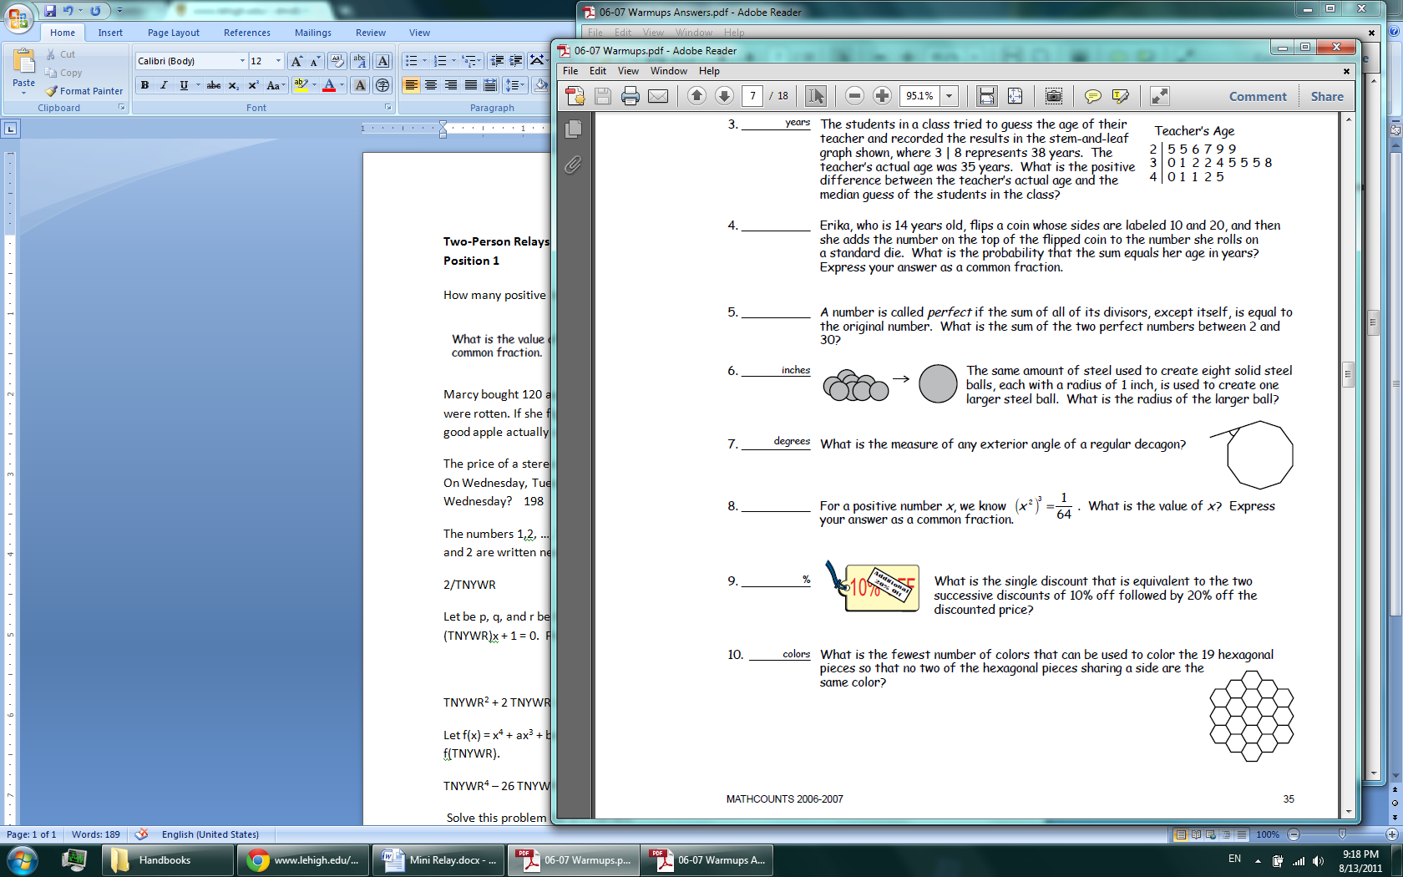3
6. What is the measure of any exterior angle of a regular decagon, in degrees?  
    36
7. Erika, who is 14 years old, flips a coin whose sides are labeled 10 and 12, and then she adds the number on the top of the flipped coin to the number she rolls on a standard die. What is the probability that the sum equals her age in years? Express your answer as a common fraction.  
   1 / 6
8. One right triangle has sides of length 3 cm, 4 cm and 5 cm. Another right triangle has two sides of length 3 cm and 4 cm, but it is not congruent to the first triangle. What is the length of the third side of this triangle? Express your answer in simplest radical form. √7
9. In the video game *World of Math*, Bill earns 12 points on his first day playing. Every day afterwards, he earns one more point than he did the day before. How many points does he earn all together over his first 77 days? 3850
10. Two cars head toward each other from opposite ends of a highway 444 km long. The speed of the first car is 85 km/hr. The speed of the second car is 100 km/hr. In how many minutes will they meet? 144

**Two-Person Relays  
Position 2**Note: express all answers in simplest form.

1. Let be p, q, and r be the three (not necessarily distinct) solutions to the equation x3 + 4x2 – (TNYWR)x + 1 = 0. Find:  
     
   TNYWR2 + 2 TNYWR + 14 = 62
2. Let a ¿ b be defined as a2 / b. What is the smallest positive integer a such that a ¿ TNYWR is an integer?  
   12
3. The numbers 1,2, …, TNYWR are written down in random order. What is the probability that 1 and 2 are written next to each other?   
   2 / TNYWR = 2 / 25
4. Let ABCD be a rectangle with AB = 3(TNYWR), BC = 4(TNYWR). Let X and Y be on the diagonal BD of ABCD such that BX > BY. Suppose A and X are two vertices of a square which has two sides on lines AB and AD, and suppose that C and Y are vertices of a square which has sides on CB and CD. Find the length XY.  
     
   5 (TNYWR) / 7 = 990 / 7
5. Let f(x) = x4 + ax3 + bx2 + cx + 25. We know that f(x)=0 has four distinct integer solutions. Find f(TNYWR).  
   TNYWR4 – 26 TNYWR2 + 25 = -128
6. What is the product of the two smallest distinct prime factors of 2TNYWR – 1? 15
7. Solve this problem for n = 1 / TNYWR. You may leave your answer unsimplified (ex: 15!/72009)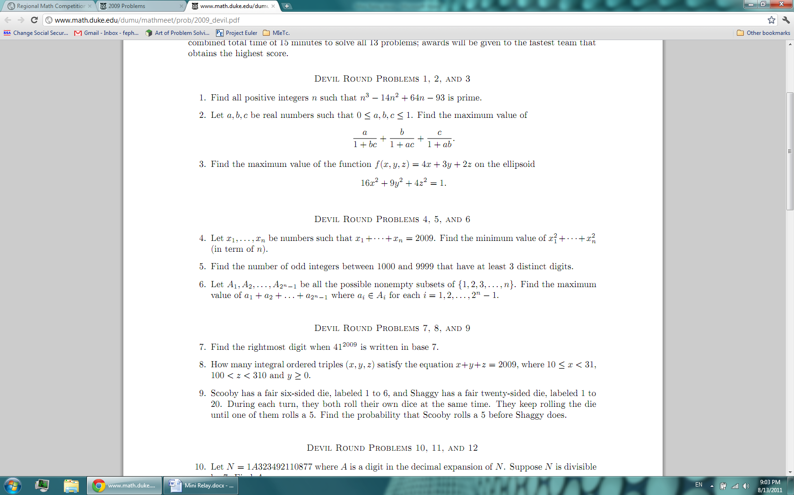20092 (TNYWR) = 20092 / 6
8. The two externally tangent circles each have a radius of TNYWR units. Each circle is tangent to three sides of the rectangle. What is the area of the shaded region?  
     
   (8 – 2π) TNYWR2 = 56 – 14π
9. For the arithmetic sequence TNYWR, TNYWR - 9, …, what is the least positive integer in the sequence? TNYWR % 9 = 7
10. Find 102011 (mod TNYWR). Hint: expect input that is a multiple of 2.  
    64